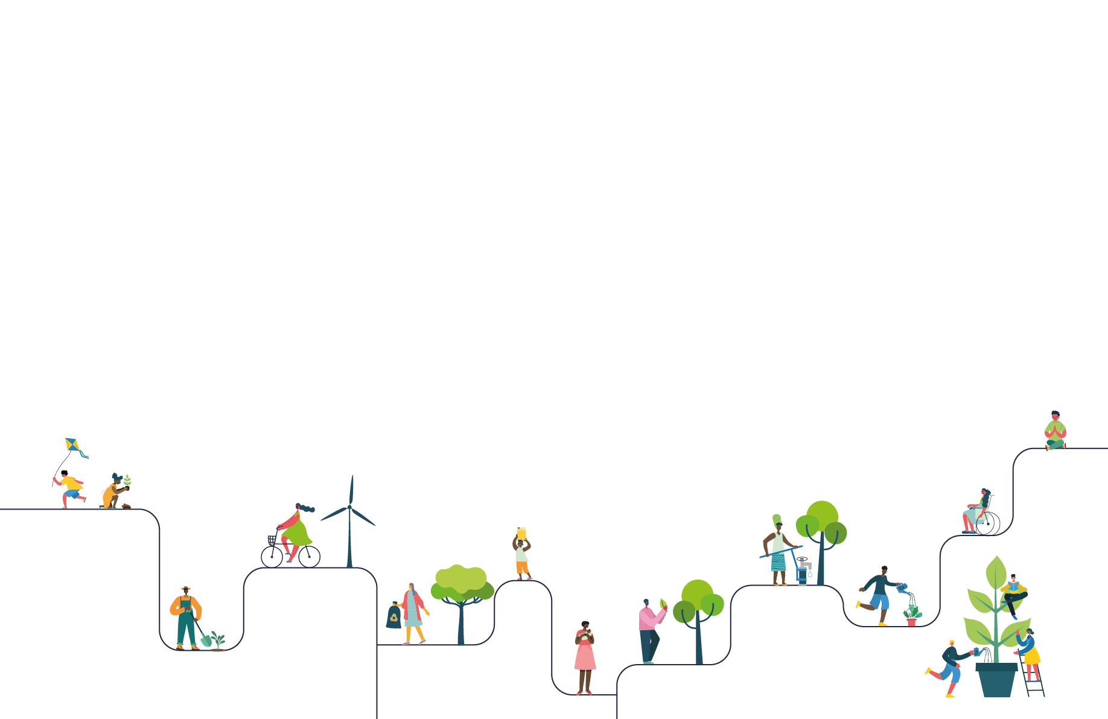
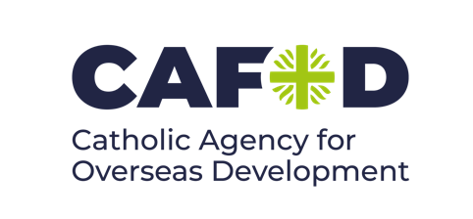


NAME OF SCHOOL : St Clare's Catholic Primary School
CONTACT NAME : Michelle Smith

The LiveSimply action planning form
Please refer to the LiveSimply action planning guide for details on how to fill out this planning document.
GLOBAL | Description of action:  Participate in CAFOD's Big Lent walk to raise funds for fishermen in Liberia  Faith Input:  “...together we want to give voice to all those who suffer, to all those who have no voice and are not heard.”  Pope Francis, 20 September 2016  CST Subsidiarity  Education input:  Assembly about the fishermen in Liberia and the dangers they face.Children will learn how we can help others through our actions, working with those in need and understand how they can make a difference in our world (Subsidairity) | Description of action:  CFairtrade reading Café and raffle in school to raise awarenes of paying a fair price to producers of cocoa, baanas and coffee  Faith Input:  “The measure of the greatness of a society is found in the way it treats those most in need, those who have nothing apart from their poverty!”  Pope Francis, 26 July 2013  CST Solidarity  Education input:  Assembly from the ECO council about how to look for the fairtrade logo which ensures farmers get paid a fair price for their produce. Children will recognise that through fairtrade, everyone benefits, making our world a fairer place (Commmon Good). | Description of action:  Participate in a colour run for CAFOD, fundraising to provide a marvelous moo cow to help communities in Bangladesh to support themselves  Faith Input:  “...we are agreed today that the earth is essentially a  shared inheritance, whose fruits are meant to benefit  everyone”’  Pope Francis, Laudato Si’, 93  CST Distributive justice  Education input:  KS2 classes examine the work CAFOD do and present an assembly. Children will learn how we can live in Solidarity with our Global neighbours. (Solidarity)
LOCAL | Description of action:  Create links with local care home where pupils will visit  Faith Input:  “Every person is worthy of our giving...they are God’s  handiwork, his creation. God created that person in  his image, and he or she reflects something of God’s  glory. Every human being is the object of God’s infinite  tenderness, and he himself is present in their lives.”  Pope Francis, Evangelii Gaudium, 274  CST human dignity  Education input:  Children will learn the importance of every member of our community. They will in turn learn how participating in such actions can fostrer relationships between generations. This is particularly pertitent in our areas as so many of the children live in isolation from grandparents. (Participation) | Description of action:  Create links with the local foodbank (Frontline) to raise awareness and food drives  Faith Input:  “The whole is greater than the part, but it is also  greater than the sum of its parts.”  Pope Francis, Evangelii Gaudium, 235.  CST The Common good  Education input:  School ECO councilors and Rights respecting ambassadors to organise food donations during harvest festival. Children will recognise the needs of others in their local community and how their small actions can help (Preferential option for the poor) | Description of action:  Take part in the 'Make a Wish Elf walk' to raise money for children with long term or terminal illness  Faith Input:  “Human persons are willed by God; they are imprinted  with God’s image. Their dignity does not come from  the work they do, but from the persons they are.”  Saint Pope John Paul II, Centesimus Annus, 11  CST Human dignity  Education input:  Rights respecting ambassadors and Mini Vinnies to help organise and run walk, speaking to classes about the purpose of the Elf Walk - helping childen who are suffering with life-limiting conditions. . (Human Dignity)
SCHOOL | Description of action:  Set up Eco club to lead whole school in sustainable actions to save energy and recycle throughout school  Faith Input:  “...the world we have received also belongs to those  who will follow us.”  Pope Francis, Laudato Si’ 159  CST Stewardship  Education input:  Eco councillors to share ideas and impliment recycling actions within classes. Each year group's councillors to encourage children to switch off lights, recycle paper, collect used batteries and food waste. Children will learn how we are all responsible for looking after the world that God has created and even the smallest actions can help. (Stewardship) | Description of action:  Create a prayer garden on our school grounds. This could be used for prayer, reflection or to simply stop and enjoy nature. We will consider pledges to look after God's world and each other. Pupil's will consider ways to look after our school grounds e.g litter picking, gradening club  Faith Input:  “Inner peace is closely related to care for ecology and  for the common good because, lived out authentically,  it is reflected in a balanced lifestyle together with  a capacity for wonder which takes us to a deeper  understanding of life.”  Pope Francis, Laudato Si’, 225  CST promoting peace  Education input:  Each class to have time in prayer garden to take part in Prayer and Liturgy. All children to be encouraged to contribute to the design and use of the prayer garden.Children will also be able to spend their own personal reflective time in prayer. | Description of action:  Create a live simply pledge wall and actions  Faith Input:  “I prefer a Church which is bruised, hurting and dirty  because it has been out on the streets, rather than a  Church which is unhealthy from being confined and  from clinging to its own security...while at our door  people are starving and Jesus does not tire of saying  to us: ‘Give them something to eat’ (Mark 6:37).”  Pope Francis, Evangelii Gaudium, 49  CST Solidarity  Education input:  Classes to share live simply powerpoint and complete live simply pledge, specifically in terms on solidarity and living simply. They will learn how living simply can bring us closer to God and His creation.

LiveSimply

Criteria for live simply: To take action towards living a simpler lifestyle including slowing down and finding time to pray and reflect, refusing and reducing on what we consume, spending more time on the simpler things in life including reflective time with family and friends, time in nature.

Brief description of main action:
Creation of a prayer garden for all members of the school community to have the opportunity for prayer and reflection. All children to have a part in the creation of the garden, having an input on what t should look like.

How will you plan for a wider community engagement?

Live simply pledges to be taken home and shared with their families, encouraging time for reflection and leading a simpler life.

FAITH | LEARN | ACT
What faith-based resources will you use?
Include resources linked to Catholic Social Teaching, liturgies, prayers and other faith based materials.
CST Promoting peace
Prayer and Liturgy to take place in the garden when possible

What educational resources will you use?
These can include CAFOD educational resources, or other resources that provide a learning journey.

Live Simply pledges
CAFOD prayers and reflections
Live Sustainably

Criteria for live sustainably: To take action towards protecting God's creation through personal actions. This can include taking action on how much we use and throw away, supporting the work of eco clubs and other eco initiatives, taking environmentally positive action in the local community.

Brief description of main action:
Inspired by Laudato Si' we will organise termly litter picks, food waste collection, paper recycling and encourage others to monitor use of electricity and water. We will aslo

https://cafod.org.uk/Education/Primary-teaching-

Pupils will watch Cafod Laudato Si Animation.
Psalm 24:1 The world and all that is in it belong to the Lord; the earth and all who live on it are his.

How will you plan for a wider community engagement?
Children to take the message home collecting batteries from home to be recycled at school, reminding others about re-using objects/clothes around the home. Saving water by turning taps off and electricity by switching lights off and not leaving electrical items on stand by

FAITH | LEARN | ACT
What faith-based resources will you use?
Include resources linked to Catholic Social Teaching, liturgies, prayers and other faith based materials.
CST stewardship, participation
https://cafod.org.uk/Education/Primary-teaching-resources/Laudato-Si-for-children

What educational resources will you use?
These can include CAFOD educational resources, or other resources that provide a learning journey.
Research ways of recycling Reducing and re-using.
Invite Representative from Gilmoss Recycling centre to share what happens there with children.

Live in Solidarity

Criteria for live in solidarity: To take direct action to help our global family. This includes campaign action to raise awareness or challenge structures that impact negatively on our global neighbours, fundraising to help communities in need, and other global actions that make a difference to our global family.
Brief description of main action:
Take part in Fairtrade fortnight, learning where food such as cocoa, bananas and coffee come from, educating them in how supermarkets can work together with farmers to give a fair price for the goods they produce. Encouraging children to look for the fairtrade logo when buying food.

How will you plan for a wider community engagement?
Parents and governors to be invited to a fairtrade café where a selection of fai.rtrade products will be available to share. The Eco councillors will be available to share their knowledge of fairtrade from the activities they have taken part in, in class.

FAITH | LEARN | ACT
What faith-based resources will you use?
Include resources linked to Catholic Social Teaching, liturgies, prayers and other faith based materials.
Catholic Social Teaching - Solidarity, Preferential Option for the poor
“The [Option for the Poor] affects the life of each Christian as he or she seeks to imitate the life of Christ.”
St Pope John Paul II, Sollicitudo Rei Socialis, 42

"For I was hungry and you gave me something to eat, I was thirsty and you gave me something to drink, I was a stranger and you invited me in" Matthew 25:35

Proverbs 11:25 Be generous, and you will be prosperous. Help others, and you will be helped.

What educational resources will you use?
These can include CAFOD educational resources, or other resources that provide a learning journey.
KS2 children take part in banana split activity from CAFOD website, which details the amount each person gets from the price of a banana.
Whole school assembly about fairtrade, ECO councillors to deliver.


To register for the LiveSimply award, please fill out the form below, and send in your completed action plan to the address below. Upon receipt of your registration we will send you a registration certificate for you to display in your school.

Name of School

Address

Headteacher

Contact Name

Email Address

Date

Please email a copy of your plan to schools@cafod.org.uk

CAFOD Education team,
Romero House,
55 Westminster Bridge Road,
London SE1 7JB.

Yes, I would like to join an email list for the LiveSimply award where I will receive updates, ideas, links to action and further support.

CAFOD will process information you provide to us on this form for the purposes of sending you resources for the LiveSimply Award. CAFOD will keep some personal details about you on our database so we can stay in contact with you enabling us to administer and manage the LiveSimply award efficiently.
You can change your communication preferences at any time by contacting us at cafod@cafod.org.uk or 0303 303 3030. CAFOD will never share your data for marketing. For details, see our privacy statement on www.cafod.org.uk/privacy

