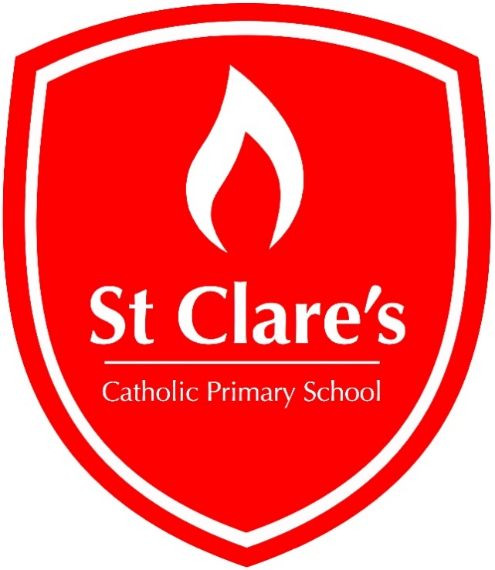

Prayer and Liturgy
Policy

2025 – 2026

Written: September 2025
Review date: September 2026
Governor Approval Date: December 2025

Mission Statement
At St Clare’s, we will let our light shine by learning together and serving others.

As an inclusive school we will work together with our families, the parish and wider community to promote equality, love and respect for all.
To encourage a lifelong love of learning that develops each individual’s full potential.
To nurture each child’s understanding of the Gospel values through learning, prayer and celebration whilst showing acceptance and sensitivity to those of other faiths and religions

- The context of this prayer and liturgy policy

‘The celebration of Catholic liturgies and prayers as an integral part of the learning and
teaching should enable the school community to become reflective, experience the
presence of God and should develop a mature spiritual life.’ (Marcus Stock (2012), Christ
at the Centre, Catholic Truth Society, 23.)

- Statement of requirement

The law requires all maintained Catholic schools to provide an act of daily collective
worship (prayer and liturgy) for all pupils, including those in the sixth form (Section 70, 1988
Education Act) that is in accordance with the rites, practices, disciplines, and liturgical
norms of the Catholic Church (School Standards and Framework Act 1998, schedule 20;
70 Instrument of Government, clause 2). Academies in England are required by their
funding agreement and Articles of Association to comply with similar requirements (The
Mainstream Academy and Free School: Supplemental Funding Agreement, December
2020; Model Articles for Catholic Academies, February 2019).

The law requires all maintained schools to recognise and respect that parents have the
legal right to withdraw their children up to the age of 16 from prayer and liturgy (School
Standards and Framework Act 1998, s.71(1A)). Sixth-form pupils can choose to withdraw
themselves from prayer and liturgy (School Standards and Framework Act 1998, s.71(1B)).
The school’s provision for prayer and liturgy will fulfil pupils’ entitlement to experience the
range of liturgical treasures of the Church, including a shared repertoire of prayers and
liturgical music with which pupils in the school will be familiar.

Prayer and liturgy are not designated curriculum time. In the context of the Catholic school,
this means that times of prayer and liturgy are not considered to be part of the allocation
of curriculum time for Religious Education.

3. Responsibility

(a) Governance
The governors, as guardians of the Catholic school’s life and mission, have a responsibility
to ensure that:
• prayer and liturgy are central to the Catholic life of the school and therefore are in line
with the guidance set out by the Prayer and Liturgy Directory
• there is a named person(s) who is responsible for prayer and liturgy in the school (the
Prayer and Liturgy Coordinator)
• the prayer and liturgy policy is updated regularly and shared with all stakeholders
• there is a budget for prayer and liturgy that reflects its centrality to the life of a
Catholic school.

(b) Headteacher
The headteacher, as the spiritual leader of the school as a Catholic community,
ensures that:
• prayer and liturgy are central to the Catholic life of the school and therefore are in line
with the guidance set out by the Prayer and Liturgy Directory
• they work in partnership with the leader(s) for prayer and liturgy
• those responsible for prayer and liturgy in the school have been given appropriate
training and formation to ensure that all guidance is followed and adhered to
• there are suitable resources for prayer and liturgy in the school.
(c) Prayer and Liturgy Coordinator
Those responsible for prayer and liturgy ensure that:
• prayer and liturgy are central to the Catholic life of the school and therefore are in line
with the guidance set out by the Prayer and Liturgy Directory
• there is an Annual Plan of Provision for prayer and liturgy across the school year which
identifies liturgical seasons and key celebrations, as well as opportunities for the
celebration of the Sacraments
• there is daily planned prayer for all pupils, appropriate to age and ability, as outlined in
the Prayer and Liturgy Directory
• pupils are supported in their liturgical formation to take an active role in the planning,
preparation, and delivery of prayer and liturgy according to their age and capacity,
and in a manner which facilitates their progressive participation
• resources to support the planning of prayer and liturgy are appropriate and readily
available to staff and pupils
• induction on prayer and liturgy takes place for new members of staff as required
• staff have access to effective training and formation opportunities
• monitoring and evaluation of prayer and liturgy take place regularly and feed back into
planning for future liturgies
• monitoring of prayer and liturgy is reported to the headteacher and governing body to
support whole-school development and the Catholic life of the school
• there is collaboration with local clergy and parishes
• liaison with the Diocesan Advisory Service and others is maintained to ensure they keep
updated with best practice.

- Overview of prayer and liturgy provision
Prayer and Liturgy at St Clare’s Catholic Primary School provides opportunities for pupils and staff to come together to worship God. It is rooted in the example and teachings of Jesus Christ whilst taking into account the religious and educational needs of all who share in it.
Daily opportunities are given for the children to pray together in class. The prayers we use can be found at the end of this policy and on our school website.
Celebration of the Word takes place daily either in class or together as a whole school. A different theme is celebrated each week. The themes can be found within this policy. Children will help, plan and lead the Celebration of the Word in an age-appropriate way.
The children are encouraged to nurture a relationship with God through words, symbols, song, gestures and silence.
All children regardless of their religion are expected to respect the opportunity for Prayer and Liturgy.
Liturgies will take place throughout the year. This helps the children to understand the Liturgical year. This can take place either in Church or school. An annual plan of provision is in place.
This plan links closely with our SMSC calendar of events.

- Resourcing

Prayer and liturgy are central to the school’s understanding of itself as a Catholic school,
and this is reflected in the annual budget allocation and available resources, including
staff time, chaplaincy provision, and dedicated spaces for prayer and liturgy. The Catholic
character of the school is reflected in religious artefacts and images on display throughout
the building. Dedicated spaces for prayer and liturgy will be furnished and maintained as
such, and updated to reflect the Church’s liturgical season. Staff training and formation
costs will be funded separately to ensure that all staff are able to fulfil their responsibility to
contribute to the prayer and liturgical life of the school.

- Training and formation

All new staff will be supported during induction and beyond, so that they fully understand
the responsibility they carry within their individual role for leading prayer and liturgy in the
school. Any individual training needs will be identified and addressed through training and
formation. There will also be the opportunity for whole-staff professional development at
least once a year, so that all staff understand the importance of prayer and liturgy and
relevant staff are well supported to lead as required.

- Monitoring and evaluation

Monitoring and evaluation of the quality and impact of prayer and liturgy will take place
regularly, and at least annually, and involve all key stakeholders: pupils, parents, staff,
clergy, and governors. Areas for development will be identified and issues raised will be
actioned and evidenced as appropriate.

- Review

The policy will be reviewed as part of the regular cycle of policy review conducted by
the governors.

Prayers Used at St Clare’s

3-5 (EYFS) | 5-7 (KS1) | 7-9(Lower KS2) | 9-11 (Upper KS2)
The Sign of the Cross | The Sign of the Cross | Morning Prayer | Morning Offering
Morning Prayer | Morning Prayer | Grace before meals | Grace before meals
Grace before meals | Grace before meals | Grace after meals | Grace after meals
Grace after meals | Grace after meals | The Apostles Creed | The Rosary
End of day prayer | The Lord’s Prayer | An Act of Contrition | The Magnificat
 | Hail Mary | Angel of God | Act of Faith
 | Glory Be | Come Holy Spirit | Act of Love
 | End of day prayer | The prayer of St Richard of Chichester | Act of Hope

